**Exercise 1: JOINS (Ch07_SaleCo)**

1. Customer Anne Farriss has called, asking for a listing of her invoice numbers and dates. 表格

   描述已自动生成
2. Corporate Management would like a list of all products sold by companies located in Florida.

1. Customer Anne Farriss called back and would like a complete account. This listing will need her name, phone number and balance, and invoice information including line items in the invoices and the line items’ product description and price.

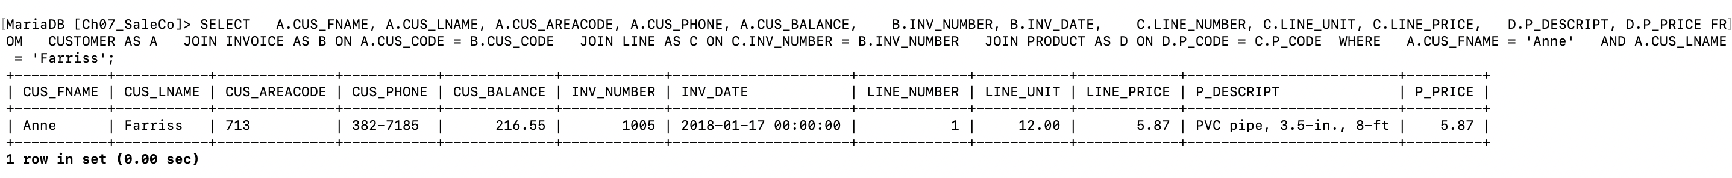

**Exercise 2: JOINS, GROUP BY, HAVING (Ch07_LargeCo)**

1. List all columns for the LGBrand table, ordered by BRAND_TYPE

1. For this same table, report the number of brands manufactured for each BRAND_TYPE. The columns should be renamed to more reasonable names.

1. For each state, list the number of customers with have non-zero balances.

1. For 3, show only states with more than 100 customers.

1. List the number of products purchased for each Brand Type, in the State of Maine (‘ME’)

1. Modify query 5 to show state/brand type product sales of less than 10 for any state.

